Assignment 2

Angular Unit Testing

(Nunit + Jasmine + Karma)

Q 1. Which testing tool is good for your Project and why (write full description and give some examples)?

Here, I have mention some of the testing tools which is used in angular project. Also mention their characteristics.

1. Karma
An open source framework developed and maintained by the GitHub community. This is the most compatible test runner for Angular known for testing on real devices. Karma provides continuous integration with various browsers with easy debugging directly from IDE.

2. Angular Mocks
A unit test expert which is Namespace from angular.mocks.js test related code. It is important to isolate the unit code which is under test for Angular 5. The inject method of Angular mock enables us to inject named Angular dependencies.

3. Mocha
This tool runs on node.js and is used with browsers for asynchronous testing. A feature-rich JS framework, Mocha test runs serially mapping uncaught exceptions to correct test cases. It has flexible and accurate reporting.

4. Jasmine
Jasmine is a behavior-driven development framework for testing JavaScript code. It does not depend on any other JavaScript frameworks. It does not require a DOM. And it has a clean, obvious syntax so that you can easily write tests.

5. Jest
Jest is a JavaScript testing framework designed to ensure correctness of any JavaScript codebase. It allows you to write tests with an approachable, familiar and feature-rich API that gives you results quickly. Jest is well-documented, requires little configuration and can be extended to match your requirements. Jest makes testing delightful.

Now, based on above functionalities Karma is the most suitable and good for our angular project because it is the most compatible test runner for Angular known for testing on real devices such as phones, tablets. It starts the browsers and runs the tests on them. It uses a configuration file in order to set the startup file, the reporters, the testing framework, the browser among other things.

Q 2. Write five sample unit test cases in Karma or Jest.

In this examples I have perform various unit test cases in my “angular-test-project” folder. Also below some of the unit test cases code snippet attached.

component only has a property “text” with the value “Angular Unit Testing”

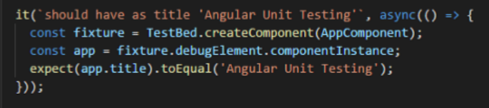

Rendered in the HTML inside an “h1” tag

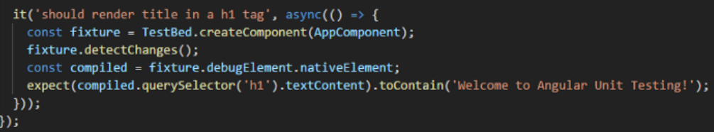

Form invalid and valid

